Anzar Naseer

21087748

**Links**: <https://github.com/anzarnaseer/ADS-Rework-Ass-2.git>

**Dataset used**:

<https://www.kaggle.com/datasets/manchunhui/world-development-indicators>

<https://www.kaggle.com/datasets/psycon/world-development-indicators>

**Github**: <https://github.com/anzarnaseergit/The-Evolution-of-Global-CO2-Emissions.git>

**From 1970 to 2016: The Evolution of Global CO2 Emissions**

**From 1970 to 2016: The Evolution of Global CO2 Emissions**

**Abstract**

This report aims to analyze the issue of global warming by investigating and analyzing CO2 emissions data using the "World Development Indicators" dataset available on the World Bank website. The report identifies the top 10 countries with the highest CO2 emissions (in kt and metric tons per capita) and examine their emissions trends.

**Introduction**

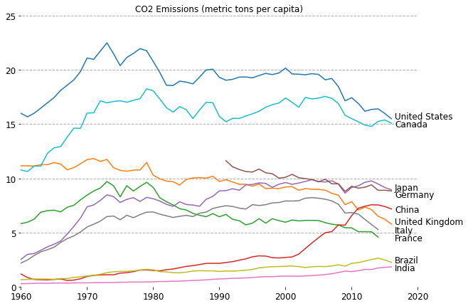The issue of global warming is currently one of the most significant challenges facing humanity. While it is widely known that the increase in atmospheric CO2 due to human activities is likely a contributing factor to global warming, it is important to investigate and analyze the data to gain a better understanding of this phenomenon. To achieve this goal, I will be using the "World Development Indicators" dataset available on the WorldBank website. Specifically, I will be focusing on the "WDIData_T.csv" and "WDICountry.csv" files to analyze CO2 emissions data. Through this analysis, I aim to answer important questions, such as identifying the top 10 countries with the highest CO2 emissions (in kt and metric tons per capita) and examining their emissions trends. The dataset contains extensive information, comprising 7,678,806 rows of data on 263 countries, with 1,437 different types of development indicators.

The line plot, I have created represents the CO2 emissions of various countries around the world, spanning from 1960 to 2020. The y-axis displays the CO2 emission values, while the x-axis represents the timeline from 1960 to 2020. The United States tops the chart with the highest CO2 emissions, followed by Canada in second place. Interestingly, Japan's data starts from 1990, indicating that no CO2 emission data was recorded before this year.

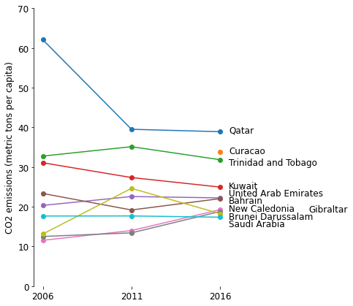As we examine the data on CO2 emissions from the top ten polluting countries, some interesting trends emerge. In 2016, Qatar, Kuwait, Trinidad and Tobago, and Saudi Arabia can be seen to have a relatively steady or even decreasing trend in their CO2 emissions per capita. This could indicate a commitment to reducing emissions or a shift toward more sustainable energy sources in these countries. However, it is important to note that 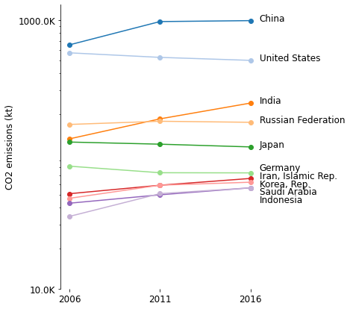their overall levels of emissions remain very high.

The line plot depicting CO2 emissions from the year 2006 to 2016 highlights a clear trend of increasing carbon emissions, with China leading the charge with a staggering 1000k CO2 emissions. On the other hand, countries such as Indonesia, Saudi Arabia, Germany, and Japan seem to have much lower CO2 emissions, with values well below the 500 mark. The data showcases the alarming levels of pollution and greenhouse gas emissions, particularly from the most industrialized nations, and emphasizes the urgent need for global action to combat climate change.

**Summary**

Upon analyzing the available data, it was discovered that a considerable number of countries, ranging from 70% to 80%, experienced a rise in their CO2 emissions (metric tons per capita or absolute CO2 emissions (kt)) during the periods of 2006-2016 or 1970-2016. While the rate of change observed between 2006 and 2016 was less than that of 1970-2016, the upward trend continues.

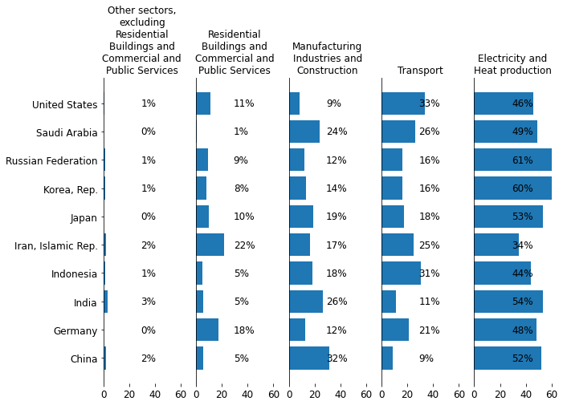When gauging relative improvements among different countries with varied population sizes, CO2 emissions (metric ton per capita) serves as a good metric. However, when determining the countries with the greatest global emissions impact, the most critical metric is absolute CO2 emissions (kt).

Furthermore, the analysis revealed that transportation, electricity, and heat production constitute an average of 70.93% of the emissions among the top ten CO2 emitters. However, variations in emissions per sector are evident across different countries, dependent on their respective economic structures. If renewable energy sources and electric vehicles are adopted more widely, there could be significant reductions in emissions. Overall, the findings suggest that urgent action is needed to address the rising trend of CO2 emissions and mitigate the effects of climate change.

Figure 1: : The top 10 CO2 emitters produce 70.93% of their emissions from transportation, electricity, and heat. Different countries have different economies, leading to variances in per-sector emission.